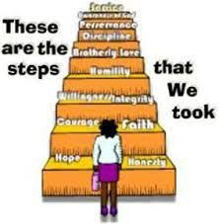
Sponsored by WAIA
2nd Annual
AA Sponsorship Conference 2020
Never Alone Again:
Walking Step by Step Together

WHERE?: Seekers Church
WHEN?: Saturday, 9/26, all day

CALL FOR SERVICE:
The Sponsorship Committee is inviting people
to join in planning this year’s conference.

Steering committee meets the first Thursday of each month,
7 p.m. Seekers Church, 276 Carroll Avenue, D.C.

Potential panel topics include:
Characteristics and Styles of Sponsors and Sponsees;
Practical Issues of being a sponsor/sponsee; Service Sponsorship; etc.

------------------------------

The first annual AA Sponsorship Conference was held on September 14, 2019. Over 100 people were in attendance and it was very well-received. Here are a few evaluation comments:
- "It's an eye-opening experience as a sponsee to better understand the relationship between sponsor and sponsee.”
- "Catch the secrets of sponsoring and being sponsored that you were afraid to ask."
- “I learned so much about practices that I want to adopt with my sponsees. What positive energy.!"

Contact Sponsorship Conference Chair (Will R) for more information.
Email: sponsorshipconference@aa-dc.org

