The 180* Club’s 38th Anniversary
Recovery Gift Basket Raffle

Take a chance and support our club… you might get lucky!

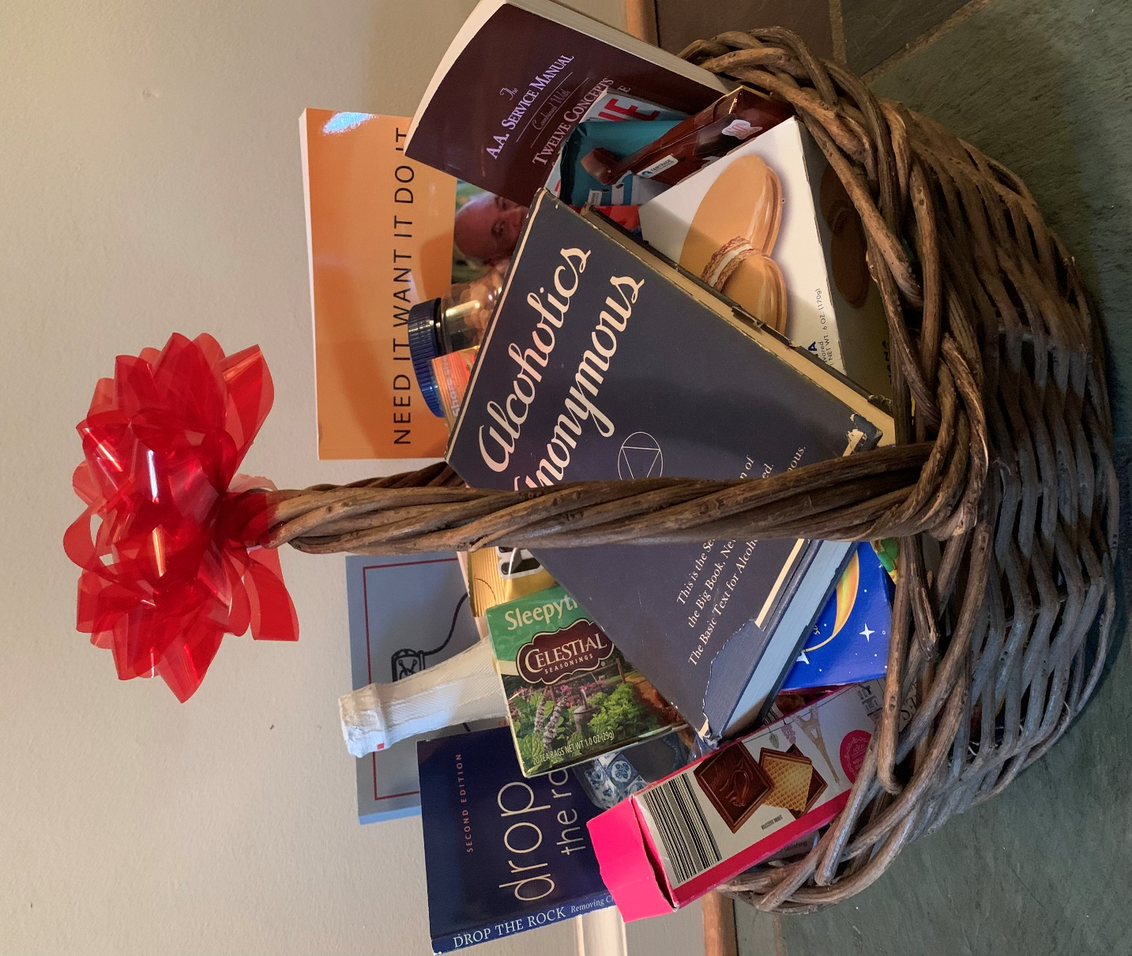

Drawing on September 26, 2021 at 7:00 PM
at the Club’s 38th Anniversary Speakers Meeting on Zoom

The 180 Club’s 38th Anniversary
The Recovery Gift Basket contains:

Alcoholics Anonymous 2nd Edition - the Big Book published in 1955! The AA Service Manual and Twelve Concepts
and more books including:
Joe and Charlie: Need It, Want It, Do It; Emotional Sobriety: The Next Frontier; One on One: Sponsorship in Action; Drop the Rock and Stools and Bottle.
Gift Basket also contains cookies, candy, chocolates, nuts, coffee, tea, sparkling apple cider and more goodies!

Raffle Tickets: $5 for one ticket or $20 for 5 tickets
All Proceeds Benefit the 180* Club!

Raffle tickets are for sale at The 180* Club -- please see the meeting chairperson to purchase -- or from Club Board members.

Contact Suzie W. for more info: hochelton@comcast.net or 301-538-4134

